NAME: hesham ashraf eldesawy

B.N: 1019

DATE:

TOPIC: Programming Languages

**APPLICATION BRIEF:**

Thousands of different programming languages have been created, and more are being created every year. Many programming languages are written in an imperative form (i.e., as a sequence of operations to perform) while other languages use the declarative form (i.e. the desired result is specified, not how to achieve it.)

The description of a programming language is usually split into the two components of syntax (form) and semantics (meaning). Some languages are defined by a specification document (for example, the C programming language is specified by an ISO Standard) while other languages (such as Perl) have a dominant implementation that is treated as a reference. Some languages have both, with the basic language defined by a standard and extensions taken from the dominant implementation being common.

**SCREEN SHOTS:**

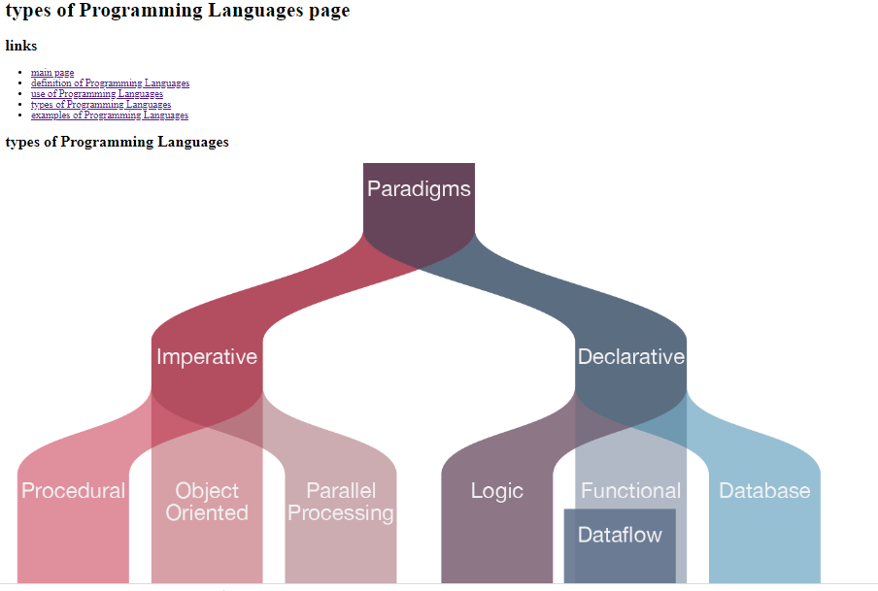

**SOURCE CODE:**

